**HEALTH CARE SYSTEM BASED ON DATA MINING CONCEPTS**

### A PROJECT REPORT

Submitted in partial fulfillment for the award of the degree of

**M.S**

***in***

**Software Engineering**

***By***

**HARISH KUMAR S**

**13MSE0029**

**ARAVINDRAJ D**

**13MSE0087**

**VIGNESH M**

**13MSE0298**

*Under the guidance of*

**Prof. NANCY VICTOR**



**School of Information Technology and Engineering**

November, 2016

**DECLARATION BY THE CANDIDATE**

We hereby declare that the project report entitled **“HEALTH CARE APPLICATION BASED ON DATA MINING CONCEPTS”** submitted by me to VIT University, Vellore in partial fulfillment of the requirement for the award of the degree of **MS(Software Engineering)** is a record of bonafide project work carried out by me under the guidance of **Prof. NANCY VICTOR.** We further declare that the work reported in this project has not been submitted and will not be submitted, either in part or in full, for the award of any other degree or diploma in this institute or any other institute or university.

**Place: Vellore HARISH KUMAR (13MSE0029)**

**Date: 9/11/2016**

**ARAVINDRAJ D (13MSE0087)**

**VIGNESH M(13MSE0298)**

## C:\Users\Dharaneesh N\Desktop\vitlogo2.jpg

## School of Information Technology & Engineering [SITE]

###### CERTIFICATE

This is to certify that the project report entitled “**HEALTH CARE APPLICATION BASED ON DATA MINING CONCEPTS”** submitted by **HARISH KUMAR S (13MSE0029), ARAVINDRAJ D (13MSE0087)** and **VIGNESH M (13MSE0298)**  to VIT University, Vellore, in partial fulfillment of the requirement for the award of the degree of M.S in Software Engineering is a record of bonafide work carried out by him/her under my guidance. The project fulfills the requirements as per the regulations of this Institute and in my opinion meets the necessary standards for submission. The contents of this report have not been submitted and will not be submitted either in part or in full, for the award of any other degree or diploma and the same is certified.

**Prof. NANCY VICTOR, Dr. Valarmathi. B**

**Assistant Professor,** **SITE Head of Department**

**INTERNAL GUIDE Department of Software and Systems Engineering**

**The project work is satisfactory / unsatisfactory**

Internal Examiner 1 Internal Examiner 2 Internal Examiner 3

**Acknowledgement**

I wish to express our heartfelt gratitude to **Dr. G. Viswanathan**, Chancellor, VIT University, Vellore for providing facilities for the Final year project.

I am highly grateful to our Vice Presidents, **Shri. Sankar Viswanathan, Dr. Sekar Viswanathan and Shri. G.V. Selvam**, Vice Chancellor **Dr. Anand A. Samuel**, Pro-Vice Chancellors **Dr. S. Narayanan** and **Dr. V. Raju** for providing necessary resources.

My sincere gratitude to **Dr. Aswani Kumar Cherukuri**, Dean, School of Information Technology and Engineering for giving us the opportunity to undertake the project.

I wish to express my sincere gratitude to **Dr. Valarmathi. B**, Associate Professor, HOD of Software and Systems Engineering and the Project Coordinators **Prof. Thilagavathi M** and **Prof. Magesh G**, School of Information Technology and Engineering for providing me an opportunity to do my project work in **VIT University.**

I would like to express my special gratitude and thanks to my internal guide **Prof. Nancy Victor,** Assistant Professor (Sr.)**,** School of Information Technology and Engineering whose esteemed guidance and immense support encouraged to complete the project successfully.

I thank the Management of VIT University for permitting me to use the library resources. I also thank all the faculty members of VIT University for giving me the courage and strength I needed to complete my goals. This acknowledgement would be incomplete without expressing my whole hearted thanks to my family and friends who motivated me during the course of the work.

**HARISH KUMAR(13MSE0029)**

**Place : Vellore**

**ARAVINDRAJ(13MSE0087)**

**Date : 9/11/2016**

**VIGNESH M(13MSE0298)**

## TABLE OF CONTENTS

|  |  |  |
| --- | --- | --- |
| Chapter No | Contents | Page No |
|  | Executive Summary | I |
|  | LIST OF FIGURES | II |
|  | LIST OF TABLES | III |
|  | LIST OF ACRONYMS | IV |
| **1** | **Introduction** | **1** |
| 1.1 | Background | 1 |
| 1.2 | Problem Statement | 1 |
| 1.3 | Importance | 1 |
| 1.4 | Organization of Report | 2 |
| **2** | **Overview and Planning** | 3 |
| 2.1 | Proposed System Overview | 3 |
| 2.2 | Challenges | 3 |
| 2.3 | Assumptions | 3 |
| 2.4 | Architecture Specifications | 4 |
| 2.5 | Hardware Requirements | 4 |
| 2.6 | Software Requirements | 4 |
| 2.7 | Project Schedule (Gantt chart) | 5 |
| 2.8 | Work Breakdown Structure | 6 |
| **3.** | **Literature Survey and Review** | 7 |
| 3.1 | Literature Survey | 7 |
| 3.2 | Literature Summary | 8 |

|  |  |  |
| --- | --- | --- |
| **4.** | **System Design** | 9 |
| 4.1 | High-Level Design | 9 |
| 4.2 | Low-Level Design | 15 |
| 4.3 | Codes and Standards | 19 |
| 4.4 | Constraints and Tradeoffs | 20 |
| 4.5 | Test Cases Generation | 21 |
| **5.** | **System Implementation** | 24 |
| 5.1 | Code | 24 |
| 5.2 | Unit Testing | 49 |
| 5.3 | Integration Testing | 49 |
| 5.4 | Test Results | 50 |
| **6.** | **Results and Discussion** | 50 |
| 6.1 | Output/Results | 50 |
| 6.2 | Results Analysis | 55 |
| 6.3 | Discussion | 55 |
| **7.** | **Conclusion and Future Work** | 56 |
| 7.1 | Conclusion | 56 |
| 7.2 | Future Works | 56 |
| **8** | **References** | 57 |

**Executive Summary**

The Health Prediction system is an end user support and online consultation project. Here we propose a system that allows users to get instant guidance on their health issues through an intelligent health care system online. The system is fed with various symptoms and the disease/illness associated with those systems. The system allows user to share their symptoms and issues. It then processes user’s symptoms to check for various illness that could be associated with it. Here we use some intelligent data mining techniques to guess the most accurate illness that could be associated with patient’s symptoms.

Now a day’s people are becoming more careless in their health issues and they are not aware like what disease will come based on current status of the health and habits and it might have happened so many times that people need doctor’s help immediately, but they are not available due to some reason. In order to create awareness to people about chance of getting health problem in future and to know what are all the precaution can be done for that particular problem.

The proposed application to predict the probability of getting affected by the disease based on the current habit and health status using data mining concepts. The application is fed with various details and the disease associated with those details. It then processes user specific details to check for illness that could be associated with it. Here we use some intelligent data mining techniques to guess the most accurate illness that could be associated with patient’s details. This system will suggest the nutrition tips based on the prediction. System will predict the disease based on previous datasets and also family history. This system also recommend the consultant doctor for the particular disease.

## LIST OF TABLES

**Table No Title Page No**

Table 2.4.1 Architecture specification 4

Table 4.1.1 User Login Table 14

Table 4.1.2 Administrator Table 14

Table 4.1.3 Diabetes Table 14

Table 4.1.4 Lung Cancer Table 14

Table 4.1.5 Medical History 14

Table 4.5.1 Login Test case 21

Table 4.5.2 Signup Test case 22

Table 4.5.3 Getting Input 22

Table 4.5.4 Analyzing dataset 23

Table 4.5.5 Analyzing user input 23

## LIST OF FIGURES

**Figure No Title Page No**

Figure 2.7:1 GANT CHARTT SCHEDULE 5

Figure 2.7:2 Gantt chart Timing 5

Figure 4.1:1 Architecture Design 9

Figure 4.1:2 DFD LEVEL 0 11

Figure 4.1:3 DFD LEVEL 1 12

Figure 4.1:4 ER DIAGRAM 13

Figure 4.2:1 Activity Diagram 15

Figure 4.2:2 USE CASE DIAGRAM 16

Figure 4.2:3 CLASS DIAGRAM 17

Figure 4.2:4 SEQUENCE DIAGRAM 18

Figure 4.2:5 STATECHART DIAGRAM 19

**LIST OF ACRONYMS**

1. CSS - Cascading Style Sheets
2. Db - Database
3. bw plot - Box-and-Whisker plots
4. DFD - Data Flow Diagram

# **Chapter 1**

# **Introduction**

# **Introduction**

This project “Health care application based on data mining concepts” is used to predict the disease of the user based on their habits and current health condition.

## Background

Now a days many of the people don’t have any knowledge about diseases. For example many peoples smoking cigarettes continuously without knowing the future consequences and problems. So the proposed system is used for creating awareness among the peoples regarding their health condition and current habits.

## Problem statement

Now a day’s people are becoming more careless in their health issues and they are not aware like what disease will come based on current status of the health and habits and it might have happened so many times that people need doctor’s help immediately, but they are not available due to some reason. In order to create awareness to people about chance of getting health problem in future and to know what are all the precaution can be done for that particular problem.

We are going to propose the application to predict the probability of getting affected by the disease based on the current habit and health status using data mining concepts. The application is fed with various details and the disease associated with those details. It then processes user specific details to check for illness that could be associated with it. Here we use some intelligent data mining techniques to guess the most accurate illness that could be associated with patient’s details.

## Importance

In some countries, the health care system has evolved and has not been planned, whereas in others a concerted effort has been made by governments, trade unions, charities, religious, or other coordinated bodies to deliver planned health care services targeted to the populations they serve. The role and the importance of health care systems in the quality of life and social welfare in modern society, have been broadly well recognized. Based on the current lifestyle of the people, this health care system plays a crucial role in the life of the people.

## Organisation of report

In the Report, the chapter one explains about the introduction describing the system importance. In the chapter two, the report explains about the overview and planning of proposed system with the challenges and assumptions of our project along with the hardware and software requirements. The chapter also explains about the Gantt-chart and workbench structure of our project. In chapter three we have discussed about the Literature Survey and summary of it.

In the chapter four, we have discussed about the system design which includes high level design , Low level design along with the codes, standards ,constraints and trade-offs of our project. Chapter five describes about the system implementation which includes codes with unit testing and integration testing. Outputs and results are described in the chapter six. Chapter Seven describes about the conclusion and future scope of our project. Finally references are clearly described in chapter eight.

# **Chapter 2**

# **Overview and Planning**

## Proposed System Overview

* The proposed system will be able to predict the diseases such as lung cancer and diabetes based on the given user details.
* The system will analyze the datasets and the inputs from the user to provide result.
* This system will suggest the nutrition tips based on the output/result.
* System will predict the disease based on previous datasets and also family history.
* This system also recommend the consultant doctor for the particular disease.

## Challenges

* Analyzing the dataset:
  + - The dataset should be analyzed with more accuracy and that too in a speedy manner.
* Analyzing the user input:
  + - The user input can be analyzed more correctly.
* Connection between R and database:
  + - The result generated in R can be stored in the database.

## Assumptions

The project assumes that the user has minimum basic knowledge on how to operate the system effectively. The system is assumed to be working correctly for proper Result. This system will predict the result more accurately.

## Architecture specifications

|  |  |
| --- | --- |
| User action | System response |
| Entering the input | Inputs are stored in database. |
| Request for result | Results are generated from the user database. |
| Request for recommendation | Test will be provided based on the user language knowledge. |
| Account updation | Updated the user account. |

Table 2.4.1 Architecture specification

## Hardware Requirement

* Processor : Pentium dual core 2.00Ghz
* Memory : 4GB
* Ram : 2GB
* Mouse : Logitech Serial Mouse
* Keyboard :Standard Keyboard

## Software Requirement

* OS : Windows 7 or latest
* Browser : Google chrome 40.0.2214 or latest
* R Studio
* XAMPP
* Apache server
* MySQL
* Html, CSS, PHP

## Project schedule (Gantt chart)

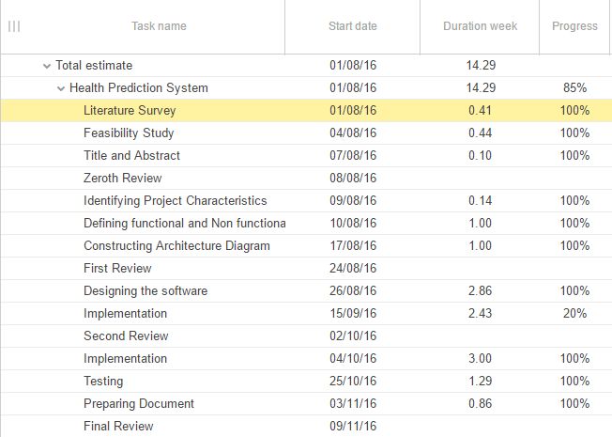

Figure 2.7:1 GANT CHART SCHEDULE

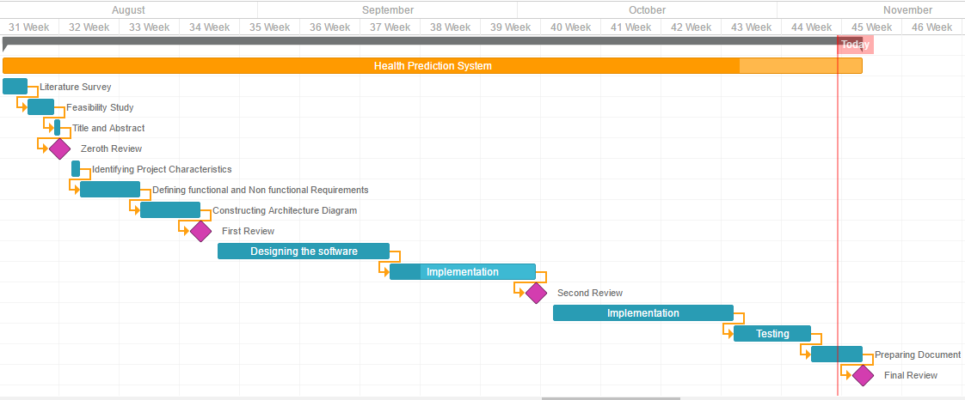

Figure 2.7:2 **Gantt chart Timin**

## Work Breakdown Structure

H:\harish.png

**2.8.1** **Work Breakdown Structure**

# **Chapter 3**

# **Literature Survey and Review**

## Literature Survey

In “Top 10 algorithms in data mining”, **Xindong Wu, Vipin Kumar, J.Ghosh, Q.Yang, H. Motoda, G.J McLachan, A.Ng, B.Liu, P.S.YU, Z-H Zhou, M.Steinbach, D.J Hand and D.Steinberg (2007)** proposed Naïve Bayes as one of the top ten data mining algorithm. They proposed Naïve Bayes algorithm is very easy to construct, not needing any complicated iterative parameter estimation schemes. This means it may be readily applied to huge data sets.

In“Application of data mining techniques in healthcare and prediction of heart attacks”, **K.Srinivas et al(2011)**, in their study, briefly examined the potential use of classification based data mining techniques such as Rule based, Decision tree, Naïve Bayes and Artificial Neural Network to massive volume of healthcare data enables significant relationships between medical factors related to heart disease. In this paper, the authors have presented an intelligent and effective heart attack prediction methods using data mining. Firstly, they have provided an efficient approach for the extraction of significant patterns from the heart disease data warehouses for the efficient prediction of heart attack Based on the calculated significant weight age, the frequent patterns having value greater than a predefined threshold were chosen for the valuable prediction of heart attack.

In **“**Intelligent and Effective Heart Disease Prediction System using Weighted Associative Classifiers “ **Jyoti Soni et al(2001)**  presented Predictive data mining for medical diagnosis. The experiments performed to compare the performance of predictive data mining technique on the same dataset and the outcome reveals that Decision Tree outperforms and sometime Bayesian classification is having similar accuracy as of decision tree but other predictive methods like KNN, Neural Networks, Classification based on clustering are not performing well.

In **“**New System Forecast E-Health Byusing Hybrid Of Association Rules And Decision Tree”, **Tayeb Sadiki and M.Boulmalf (2014)** presented new solution for complete monitoring for e-health system data mining by the hybrid use of association rules and decision tree. That ensures acquires and decision speed of execution in real time and monitoring chronic illness by their system.

In“Clustering of Lung Cancer Data using Foggy K-Means” **,Akhilesh Kumar Yadav, Divya Tomar, Sonali Agarwal(2013)** proposal model for effectively utilize the Available information and find out the factors which causes lung cancer. In this paper a novel clustering algorithm has been presented with powerful diagnostic features for the prevention of lung cancer. The proposed Foggy K-means approach has more accurate clusters could be utilized by domain experts for their strategic planning. In the similar fashion we can correlate ill-effects of smoking, tuberculosis and various diseases.

## Literature Summary

Naïve Bayes algorithm is very easy to construct, not needing any complicated iterative parameter estimation schemes. This means it may be readily applied to huge data sets.so we are used naïve Bayes algorithm in our proposed system to analyze the datasets and user input. Naive Bayes algorithm requires less time to analyze and classify the datasets. The system to predict health status of the individuals will be more accurate and reliable.

# **Chapter 4**

# **System Design**

## High Level Design

### Architecture Design

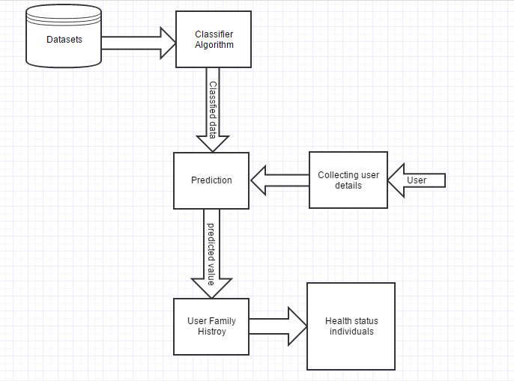

Figure 4.1:1 **Architecture Design**

**Module Description:**

1. **Datasets**

Dataset is a collection of related sets of information that is composed of separate elements but can be manipulated as a unit by a computer. Most commonly a data set corresponds to the contents of a single database table, or a single statistical data matrix, where every column of the table represents a particular variable, and each row corresponds to a given member of the data set in question.

1. **Classifier Algorithm**

A Classification Algorithm is a procedure for selecting a hypothesis from a set of alternatives that best fits a set of observations.

1. **Prediction**

Large amounts of sensor data have to be “interpreted” to acquire knowledge about tasks that occur in the environment. Patterns in the data can be used to predict future events. Not necessarily future events, just unknowns.

1. **Collecting User Details**

In this module, the details of the user such as their symptoms can be collected.

1. **User Family History**

The information about their Family history also be collected.

1. **Health Status individuals**

Based on the details provided by the user, their health status could be provided.

### DATAFLOW DIAGRAM

**Level 0:**

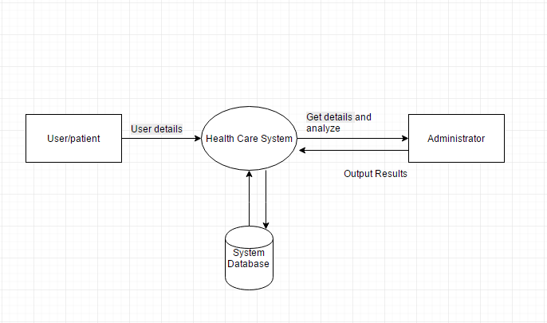

Figure 4.1:2 DFD LEVEL 0

**Level 1:**

H:\harish\Level 1 DFD (1).png

Figure 4.1:3 DFD LEVEL 1

### ER Diagram:

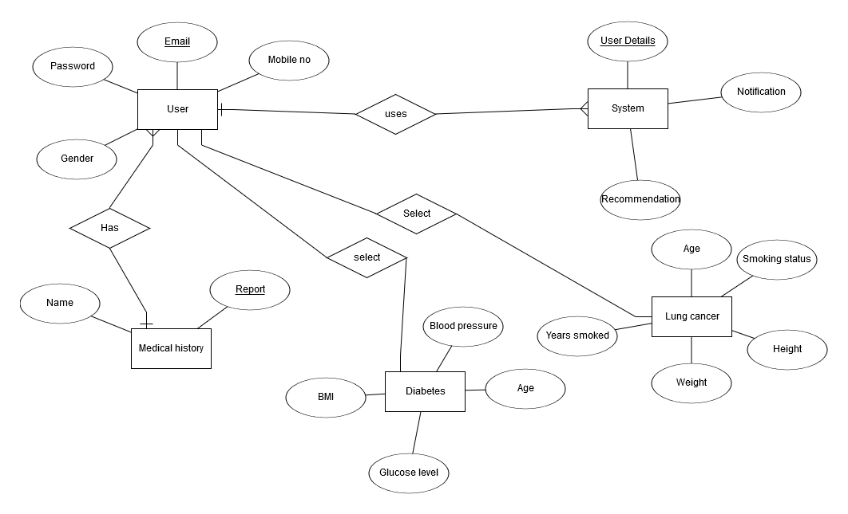

Figure 4.1:4 ER DIAGRAM

**Description of tables:**

**Table: User**

|  |  |  |  |  |
| --- | --- | --- | --- | --- |
| Email id | Password | Name | Gender | Mobile no |

Table 4.1.1 User Login Table

**Table: Administrator**

|  |  |
| --- | --- |
| Administrator id | Password |

Table 4.1.2Administrator Table

**Table: Diabetes**

|  |  |  |  |  |  |  |  |
| --- | --- | --- | --- | --- | --- | --- | --- |
| No of times pregnant | Plasma glucose concentration | blood pressure | skin fold thickness | insulin | BMI | Age | Diabetes pedigree function |

Table 4.1.3Diabetes Table

**Table: Lung Cancer**

|  |  |  |  |  |  |  |  |  |
| --- | --- | --- | --- | --- | --- | --- | --- | --- |
| Age | Smoking status | Years smoked | Avg per day | Grade | height | weight | Gender | COPD |

Table 4.1.4 Lung Cancer Table

**Table: Medical History**

|  |  |
| --- | --- |
| User Name | Report |

Table 4.1.5Medical History

## Low Level Design

### Activity Diagram

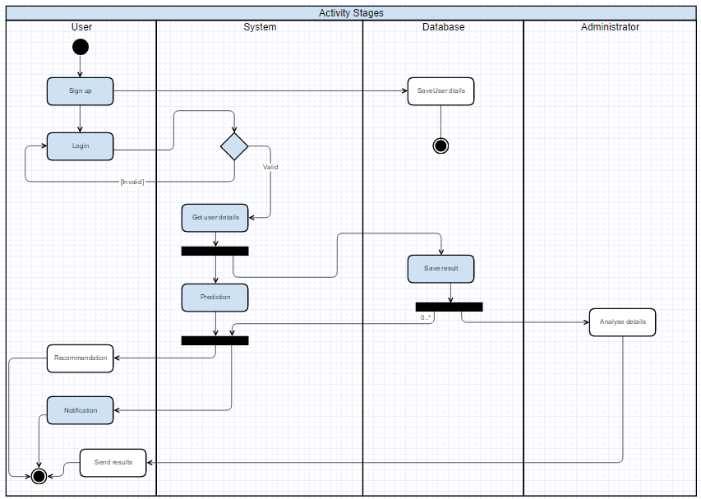

Figure 4.2:1Activity Diagram

Activity diagram are representations of flow of control. This diagram describes dynamic aspects of the system. The above diagram shows the overall flow between user, admin and system and how the database stores the data.

### Use Case Diagram

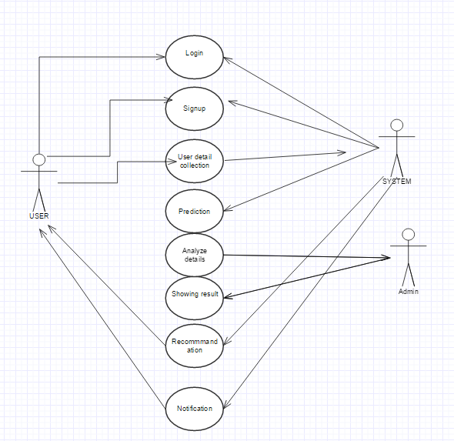

Figure 4.2:2 Use Case Diagram

A use case diagram is a methodology used in system analysis to identify, clarify and organize system requirements. The above figure shows the interaction between actors and the system.

### Class Diagram

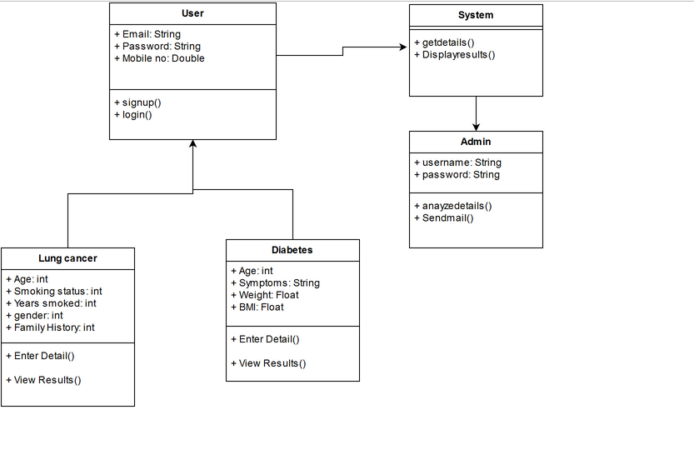

Figure 4.2:3 Class Diagram

A **class diagram** in the Unified Modeling Language (UML) is a type of static structure diagram that describes the structure of a system by showing the system's classes, their attributes, operations (or methods), and the relationships among objects.

### Sequence Diagram

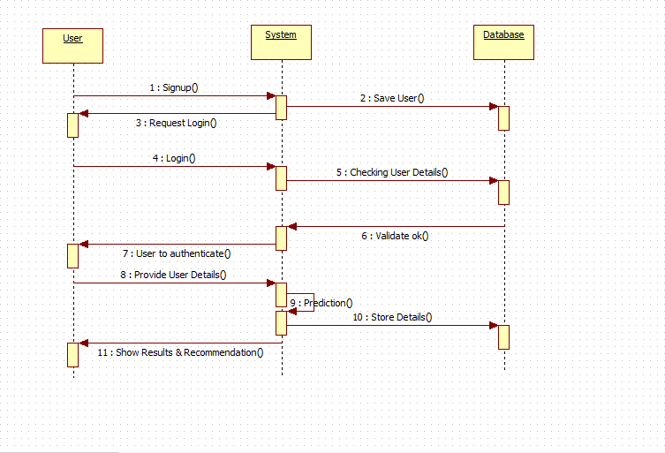

Figure 4.2:4 Sequence Diagram

A Sequence diagram is an interaction diagram shows how process operate with one another and in what order. The above figure shows object interactions arranged in time sequence between user, system and database.

### State chart Diagram

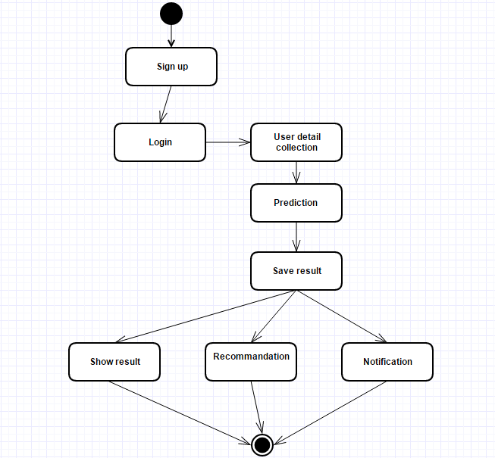

Figure 4.2:5 STATECHART DIAGRAM

## Code and Standards

The application is developed using Hyper Text Mark-up Language (HTML), Hypertext Preprocessor (PHP) and R language. The PHP followed the PSR-2 standard for code formatting. All HTML pages should be verified against the W3C validator to ensure that the markup is well formed.

**R** is a programming language and software environment for statistical computing and graphics supported by the R Foundation for Statistical Computing. The R language is widely used among statisticians and data miners for developing statistical software and data analysis.

**phpMyAdmin** is a free and open source tool written in PHP intended to handle the administration of MySQL or Maria DB with the use of a web browser. It can perform various tasks such as creating, modifying or deleting databases, tables, fields or rows; executing SQL statements; or managing users and permissions.

## Constraints and Trade offs

**Constraints**

The constraints considered for our project was the project should be finished on time and the accuracy of our system should be higher. The accuracy of the system will be high and time required for analysing the dataset would be less.

**Trade off**

We use Naïve Bayes algorithm to reduce the time required for analyzing the dataset. Naive Bayes algorithm takes less time to analyze the dataset and the efficiency of the prediction is also high. We use other methods for effective and efficient generation of output.

## Test case generation

### TEST CASE #1: Login

Login is the process by which an individual gains access to a computer system by identifying and authenticating themselves. The user credentials are typically some form of "username" and a matching "password" so that user can able to authenticate in their account.

|  |  |  |  |  |  |
| --- | --- | --- | --- | --- | --- |
| TEST ID | TEST STEPS | TEST DATA | EXPECTED OUTPUT | ACTUAL OUTPUT | TEST RESULT |
| 1 | Login | Username:  harish@gmail.com  Password:  ramukhsirah | Navigate to Home page | Navigate to Home page | Pass |
| 2 | Login | Username:  vignesh@gmail.com  Password:  asdf | Login failed | Login failed  (Not Authenticated user) | Pass |
| 3 | Login | Username:  aravindh  Password:  1234 | Login failed | Login failed  (Wrong format) | Pass |
| 4 | Login | Username:  Null(no value)  Password:  abcd | Login failed | Login failed  (Null values) | Pass |
| 5 | Login | Username:  abc@gmail.com  Password:  abcd | Login failed | Navigate to Home page | Fail |

Table 4.5.1 **Login Test case**

### TEST CASE #2: Signup

**Description:**

The user have to register their details to access the system.

|  |  |  |  |  |  |
| --- | --- | --- | --- | --- | --- |
| TEST ID | TEST STEPS | TEST DATA | EXPECTED OUTPUT | ACTUAL OUTPUT | TEST RESULT |
| 1 | Signing up | All values are provided | Navigate to login page | Navigate to login page | Pass |
| 2 | Signing up | Null/Wrong values are provided | Show error | Show error | Pass |
| 3 | Signing up | Null/Wrong values are provided | Show error | Navigate to login page | Fail |

Table 4.5.2 **Signup Test case**

### TEST CASE #3: Getting Input from User

**Description:**

The system will get the input from the user and produce the result based in the given inputs.

|  |  |  |  |  |  |
| --- | --- | --- | --- | --- | --- |
| TEST ID | TEST STEPS | TEST DATA | EXPECTED OUTPUT | ACTUAL OUTPUT | TEST RESULT |
| 1 | Getting user details | Giving input to all fields | Result will be given | Result will be given | Pass |
| 2 | Getting user details | Wrong input | Show errors | Show errors | Pass |
| 3 | Getting user details | Correct data | Give results | Show errors | Fail |

Table 4.5.3 Getting Input

### TEST CASE #4: Analyzing Dataset

**Description:**

Dataset is a collection of related sets of information that is composed of separate elements but can be manipulated as a unit by a computer. Dataset can be analyzed and classified to give desired results.

|  |  |  |  |  |  |
| --- | --- | --- | --- | --- | --- |
| TEST ID | TEST STEPS | TEST DATA | EXPECTED OUTPUT | ACTUAL OUTPUT | TEST RESULT |
| 1 | Analyzing Dataset | Giving correct Dataset | Analyzing the dataset | Analyzing the dataset | Pass |
| 2 | Analyzing Dataset | Giving wrong Dataset | Shows error | Shows error  (Because of wrong dataset name given) | Pass |
| 3 | Analyzing Dataset | Giving correct Dataset | Analyzing the dataset | Shows error | Fail |

Table 4.5.4 Analyzing dataset

### TEST CASE #5: Analyzing User Input

**Description:**

The user input are analyzed and based on the input the system can provide the result.

|  |  |  |  |  |  |
| --- | --- | --- | --- | --- | --- |
| TEST ID | TEST STEPS | TEST DATA | EXPECTED OUTPUT | ACTUAL OUTPUT | TEST RESULT |
| 1 | Analyzing Input from the user | User input | Result based on input | Result provided | Pass |
| 2 | Analyzing Input from the user | Wrong User input | Show errors | Show errors | Pass |
| 3 | Analyzing Input from the user | User input | Result based on input | Error generated  (may be system failure ) | Fail |

Table 4.5.5 Analyzing user input

# **Chapter 5**

# **System Implementation**

## Code

**Login.php**

<?php

session_start();

?>

<html>

<head>

<!--Import materialize.css-->

<link type="text/css" rel="stylesheet" href="css/materialize.min.css" media="screen,projection"/>

<link type="text/css" rel="stylesheet" href="css/style.css" media="screen,projection"/>

<!--Let browser know website is optimized for mobile-->

<meta name="viewport" content="width=device-width, initial-scale=1.0"/>

<link href="https://fonts.googleapis.com/icon?family=Material+Icons" rel="stylesheet">

<style>

nav{

background-color:#212121;

}

</style>

<script type="text/javascript">

function l()

{

$(document).ready(function(){

// the "href" attribute of .modal-trigger must specify the modal ID that wants to be triggered

$('.modal-trigger').leanModal();

});

}

</script>

</head>

<body onload="l();">

<!--Import jQuery before materialize.js-->

<script type="text/javascript" src="https://code.jquery.com/jquery-2.1.1.min.js"></script>

<script type="text/javascript" src="js/materialize.min.js"></script>

<script type="text/javascript" src="js/parallax.js"></script>

<ul id="dropdown1" class="dropdown-content">

<!-- <li><a href="account.php">My Account</a></li>-->

<li><a href="">My result</a></li>

<li><a href="index.php">Logout</a></li>

<li class="divider">My Profile</li>

<li><a href="#!"></a></li>

</ul>

<nav class="navbar-fixed">

<div class="nav-wrapper">

<a href="#!" class="brand-logo"> </a>

<ul class="right hide-on-med-and-down">

<li><a href=""><font color="white"><b></b></font></a></li>

<!-- Dropdown Trigger -->

<li><a class="dropdown-button" href="#!" data-activates="dropdown1"> <font color="white">

<?php

$servername = "localhost";

$username = "root";

$password = "";

$dbname = "user";

$name=$_SESSION['email'];

// Create connection

$conn = new mysqli($servername, $username, $password, $dbname);

// Check connection

if ($conn->connect_error) {

die("Some error occured." . $conn->connect_error);

}

$sql="select * from user_details where email='".$name."' ";

$result = $conn->query($sql);

if ($result->num_rows > 0) {

// output data of each row

while($row = $result->fetch_assoc()) {

echo $row['fname'];

}

}

$conn->close();

?><i class="material-icons left">perm_identity</i></font></a></li>

</ul>

</div>

</nav>

<!-- parallax-->

<div class="parallax-container valign-wrapper">

<div class="section no-pad-bot">

<div class="container">

<div class="row center">

<h2 class="header col s12 light">We are always there to guide you.</h2>

</div>

</div>

</div>

<div class="parallax"><img src="1/da69268193355858397983d57f7fc07b.jpg" alt="Unsplashed background img 2"></div>

</div>

<br>

<br>

<div class="container">

<div class="row">

<center><b><h4>Please select for what disease you want predict</h4></b></center>

<br>

<div class="input-field col s6"><br><center>

<a href="lung form.php"><button class="btn waves-effect waves-light" type="submit" name="action" >Lung cancer</button>

</a>

</center>

</div>

<div class="input-field col s6"><br><center>

<a href="diabet3.php">

<button class="btn waves-effect waves-light" type="submit" name="action" >Diabetics</button>

</a>

</center>

</div>

</div>

</div>

<br>

<br>

<!--footer-->

<footer class="page-footer" style="background-color:#212121;">

<div class="container">

<div class="row">

<div class="col l6 s12">

<h5 class="white-text">Health care system</h5>

<p class="grey-text text-lighten-4">We are here to always help you.</p>

</div>

<div class="col l4 offset-l2 s12">

<h5 class="white-text"></h5>

<ul>

<li><a class="grey-text text-lighten-3" href="#Login"></a></li>

<li><a class="grey-text text-lighten-3" href="#signup"></a></li>

</ul>

</div>

</div>

</div>

<div class="footer-copyright">

<div class="container">

<a class="grey-text text-lighten-4 right" href="#!"></a>

</div>

</div>

</footer>

</body>

</html>

**Lungform.php**

<?php

session_start();

?>

<html>

<head>

<link type="text/css" rel="stylesheet" href="css/materialize.min.css" media="screen,projection"/>

<link type="text/css" rel="stylesheet" href="css/style.css" media="screen,projection"/>

<meta name="viewport" content="width=device-width, initial-scale=1.0"/>

<link href="https://fonts.googleapis.com/icon?family=Material+Icons" rel="stylesheet">

<style>

nav{

background-color:#212121;

}

</style>

<script type="text/javascript">

function l()

{

$(document).ready(function(){

$('.modal-trigger').leanModal();

});

}

</script>

</head>

<body onload="l();">

<script type="text/javascript" src="https://code.jquery.com/jquery-2.1.1.min.js"></script>

<script type="text/javascript" src="js/materialize.min.js"></script>

<script type="text/javascript" src="js/parallax.js"></script>

<ul id="dropdown1" class="dropdown-content">

<!-- <li><a href="account.php">My Account</a></li>-->

<li><a href="">My result</a></li>

<li><a href="index.php">Logout</a></li>

<li class="divider">My Profile</li>

<li><a href="#!"></a></li>

</ul>

<nav class="navbar-fixed">

<div class="nav-wrapper">

<a href="#!" class="brand-logo"> </a>

<ul class="right hide-on-med-and-down">

<li><a href="diabet3.php"><font color="white"><b>for Diabetics</b></font></a></li>

<!-- Dropdown Trigger -->

<li><a class="dropdown-button" href="#!" data-activates="dropdown1"> <font color="white">

<?php

$servername = "localhost";

$username = "root";

$password = "";

$dbname = "user";

$name=$_SESSION['email'];

// Create connection

$conn = new mysqli($servername, $username, $password, $dbname);

// Check connection

if ($conn->connect_error) {

die("Some error occured." . $conn->connect_error);

}

$sql="select * from user_details where email='".$name."' ";

$result = $conn->query($sql);

if ($result->num_rows > 0) {

// output data of each row

while($row = $result->fetch_assoc()) {

echo $row['fname'];

}

}

$conn->close();

?><i class="material-icons left">perm_identity</i></font></a></li>

</ul>

</div>

</nav>

<!-- parallax-->

<div class="parallax-container valign-wrapper">

<div class="section no-pad-bot">

<div class="container">

<div class="row center">

<h2 class="header col s12 light">We are always there to guide you.</h2>

</div>

</div>

</div>

<div class="parallax"><img src="1/da69268193355858397983d57f7fc07b.jpg" alt="Unsplashed background img 2"></div>

</div>

<br>

<br>

<div class="container">

<div class="row">

<center><b><h3>Please fill the form.</h3></b></center>

<br>

<form class="col s12" method="get" action="Database_save.php">

<div class="row">

<div class="input-field col s2">

<br>

<i class="medium material-icons">label_outline</i></div>

<div class="input-field col s10">

<textarea id="textarea1" class="materialize-textarea" name="age"></textarea>

<label for="textarea1">Age</label>

</div>

</div>

<div class="row">

<div class="input-field col s2">

<br>

<i class="medium material-icons">label_outline</i>

</div>

<br>

<br>

<input class="with-gap" name="status" type="radio" id="test1" value="Smoker"/>

<label for="test1">Smoker</label>

<input class="with-gap" name="status" type="radio" id="test2" value="Former Smoker"/>

<label for="test2">Former-Smoker</label>

<input class="with-gap" name="status" type="radio" id="test3" value="Non Smoker"/>

<label for="test3">Non-Smoker</label>

</div>

<div class="row"> <div class="input-field col s2">

<br>

<i class="medium material-icons">label_outline</i></div>

<div class="input-field col s10">

<textarea id="textarea1" class="materialize-textarea" name="yearsmoked"></textarea>

<label for="textarea1">Years smoked</label>

</div>

</div>

<div class="row">

<div class="input-field col s2">

<br>

<i class="medium material-icons">label_outline</i></div>

<div class="input-field col s10">

<textarea id="textarea1" class="materialize-textarea" name="avecig"></textarea>

<label for="textarea1">Average cigarette per day</label>

</div>

</div>

<div class="row">

<div class="input-field col s2">

<br>

<i class="medium material-icons">label_outline</i></div>

<br>

<br>

<input class="with-gap" name="gender" type="radio" id="test7" value="male" />

<label for="test7">Male</label>

<input class="with-gap" name="gender" type="radio" id="test8" value="female"/>

<label for="test8">Female</label>

</div>

<div class="row">

<div class="input-field col s2">

<br>

<i class="medium material-icons">label_outline</i></div>

<br>

<br>

<input class="with-gap" name="highgrade" type="radio" id="test9" value="Under graduate" />

<label for="test9">Under graduate</label>

<input class="with-gap" name="highgrade" type="radio" id="test10" value="Post graduate"/>

<label for="test10">Post graduate</label>

<input class="with-gap" name="highgrade" type="radio" id="test11" value="highgrade"/>

<label for="test11">nil</label>

</div>

<div class="row">

<div class="input-field col s2">

<br>

<i class="medium material-icons">label_outline</i></div>

<br>

<br>

<input class="with-gap" name="race" type="radio" id="test12" value="male" />

<label for="test12">Asian</label>

<input class="with-gap" name="race" type="radio" id="test13" value="female"/>

<label for="test13">American Indian</label>

<input class="with-gap" name="race" type="radio" id="test14" value="female"/>

<label for="test14">African Indian</label>

<input class="with-gap" name="race" type="radio" id="test15" value="female"/>

<label for="test15">White</label>

<input class="with-gap" name="race" type="radio" id="test16" value="female"/>

<label for="test16">Latino</label>

</div>

<div class="row">

<div class="input-field col s2">

<br>

<i class="medium material-icons">label_outline</i></div>

<div class="input-field col s10">

<textarea id="textarea1" class="materialize-textarea" name="height"></textarea>

<label for="textarea1">Height in cm</label>

</div>

</div>

<div class="row">

<div class="input-field col s2">

<br>

<i class="medium material-icons">label_outline</i></div>

<div class="input-field col s10">

<textarea id="textarea1" class="materialize-textarea" name="weight"></textarea>

<label for="textarea1">Weight</label>

</div>

</div>

<div class="row">

<div class="input-field col s2">

<br>

<i class="medium material-icons">label_outline</i></div>

<br>

<p>Does doctor said you have cancer</p>

<input class="with-gap" name="cancer" type="radio" id="test17" value="yes" />

<label for="test17">Yes</label>

<input class="with-gap" name="cancer" type="radio" id="test18" value="no"/>

<label for="test18">No</label>

</div>

<div class="row">

<div class="input-field col s2">

<br>

<i class="medium material-icons">label_outline</i></div>

<br>

<p>Does anyone has cancer in your family</p>

<input class="with-gap" name="familyhistory" type="radio" id="test19" value="yes" />

<label for="test19">Yes</label>

<input class="with-gap" name="familyhistory" type="radio" id="test20" value="no"/>

<label for="test20">No</label>

</div></div>

<div class="row">

<div class="input-field col s2">

<br>

<i class="medium material-icons">label_outline</i></div>

<br>

<p>Chronic obstructive pulmonary disease(copd)</p>

<input class="with-gap" name="copd" type="radio" id="test21" value="yes" />

<label for="test21">Yes</label>

<input class="with-gap" name="copd" type="radio" id="test22" value="no"/>

<label for="test22">No</label>

</div>

</div>

<div class="input-field col s12"><br><center>

<a href="index.php"> <button class="btn waves-effect waves-light" type="submit" name="action" >Submit</button></a>

</center></div>

<br>

</form>

</div>

</div>

<!--footer-->

<footer class="page-footer" style="background-color:#212121;">

<div class="container">

<div class="row">

<div class="col l6 s12">

<h5 class="white-text">Health care system</h5>

<p class="grey-text text-lighten-4">We are here to always help you.</p>

</div>

<div class="col l4 offset-l2 s12">

<h5 class="white-text">Quick links</h5>

<ul>

<li><a class="grey-text text-lighten-3" href="#Login">Login</a></li>

<li><a class="grey-text text-lighten-3" href="#signup">Sign up</a></li>

</ul>

</div>

</div>

</div>

<div class="footer-copyright">

<div class="container">

<a class="grey-text text-lighten-4 right" href="#!"></a>

</div>

</div>

</footer>

</body>

</html>

<html>

<head>

<!--Import materialize.css-->

<link type="text/css" rel="stylesheet" href="css/materialize.min.css" media="screen,projection"/>

<link type="text/css" rel="stylesheet" href="css/style.css" media="screen,projection"/>

<!--Let browser know website is optimized for mobile-->

<meta name="viewport" content="width=device-width, initial-scale=1.0"/>

<link href="https://fonts.googleapis.com/icon?family=Material+Icons" rel="stylesheet">

<style>

nav{

background-color:#212121;

}

</style>

<script type="text/javascript">

function l()

{

$(document).ready(function(){

// the "href" attribute of .modal-trigger must specify the modal ID that wants to be triggered

$('.modal-trigger').leanModal();

});

}

</script>

</head>

**Diabetes.php**

<?php

session_start();

<body onload="l();">

<!--Import jQuery before materialize.js-->

<script type="text/javascript" src="https://code.jquery.com/jquery-2.1.1.min.js"></script>

<script type="text/javascript" src="js/materialize.min.js"></script>

<script type="text/javascript" src="js/parallax.js"></script>

<ul id="dropdown1" class="dropdown-content" id="dropdown-content1">

<!-- <li><a href="account.php">My Account</a></li>-->

<li><a href="">My result</a></li>

<li><a href="index.php">Logout</a></li>

<li class="divider">My Profile</li>

<li><a href="#!"></a></li>

</ul>

<nav class="navbar-fixed">

<div class="nav-wrapper">

<a href="#!" class="brand-logo"> </a>

<ul class="right hide-on-med-and-down">

<li><a href="lung form.php"><font color="white"><b>for lung cancer</b></font></a></li>

<!-- Dropdown Trigger -->

<li><a class="dropdown-button" href="#!" data-activates="dropdown1"> <font color="white"> <?php

$servername = "localhost";

$username = "root";

$password = "";

$dbname = "user";

$name=$_SESSION['email'];

// Create connection

$conn = new mysqli($servername, $username, $password, $dbname);

// Check connection

if ($conn->connect_error) {

die("Some error occured." . $conn->connect_error);

}

$sql="select * from user_details where email='".$name."' ";

$result = $conn->query($sql);

if ($result->num_rows > 0) {

// output data of each row

while($row = $result->fetch_assoc()) {

echo $row['fname'];

}

}

$conn->close();

?><i class="material-icons left">perm_identity</i></font></a></li>

</ul>

</div>

</nav>

<!-- parallax-->

<div class="parallax-container valign-wrapper">

<div class="section no-pad-bot">

<div class="container">

<div class="row center">

<h2 class="header col s12 light">We are always there to guide you.</h2>

</div>

</div>

</div>

<div class="parallax"><img src="1/da69268193355858397983d57f7fc07b.jpg" alt="Unsplashed background img 2"></div>

</div>

<br>

<br>

<div class="container">

<div class="row">

<center><b><h3>Please fill the form.</h3></b></center>

<br>

<form class="col s12" method="POST" action="">

<div class="row">

<div class="input-field col s2">

<br>

<i class="medium material-icons">label_outline</i></div>

<br>

<p>What is your Gender?</p>

<input class="with-gap" name="gender" type="radio" id="test1" value="yes" />

<label for="test1">Male</label>

<input class="with-gap" name="gender" type="radio" id="test2" value="no"/>

<label for="test2">Female</label> <span class="error"> <?php echo $gErr;?></span>

</div>

<div class="row">

<div class="input-field col s2">

<br>

<i class="medium material-icons">label_outline</i></div>

<br>

<p>Are You Feeling Thirsty Always?</p>

<input class="with-gap" name="thirsty" type="radio" id="test3" value="yes" />

<label for="test3">Yes</label>

<input class="with-gap" name="thirsty" type="radio" id="test4" value="no"/>

<label for="test4">No</label>

</div>

<div class="row">

<div class="input-field col s2">

<br>

<i class="medium material-icons">label_outline</i></div>

<br>

<p>Are You Suffering from Frequent Urination? </p>

<input class="with-gap" name="urination" type="radio" id="test5" value="yes" />

<label for="test5">Yes</label>

<input class="with-gap" name="urination" type="radio" id="test6" value="no"/>

<label for="test6">No</label>

</div>

<div class="row">

<div class="input-field col s2">

<br>

<i class="medium material-icons">label_outline</i></div>

<br>

<p>Are You Suffering from Exces Hunger? </p>

<input class="with-gap" name="hunger " type="radio" id="test7" value="yes" />

<label for="test7">Yes</label>

<input class="with-gap" name="hunger " type="radio" id="test8" value="no"/>

<label for="test8">No</label>

</div>

<div class="row">

<div class="input-field col s2">

<br>

<i class="medium material-icons">label_outline</i></div>

<br>

<p>Do you have Weight Loss?</p>

<input class="with-gap" name="loss" type="radio" id="test9" value="yes" />

<label for="test9">Yes</label>

<input class="with-gap" name="loss" type="radio" id="test10" value="no"/>

<label for="test10">No</label>

</div>

<div class="row">

<div class="input-field col s2">

<br>

<i class="medium material-icons">label_outline</i></div>

<br>

<p>Are you Over Weight?</p>

<input class="with-gap" name="weight" type="radio" id="test11" value="yes" />

<label for="test11">Yes</label>

<input class="with-gap" name="weight" type="radio" id="test12" value="no"/>

<label for="test12">No</label>

</div>

<div class="row">

<div class="input-field col s2">

<br>

<i class="medium material-icons">label_outline</i></div>

<br>

<p>Are You Suffering from Weight Fluctuation?</p>

<input class="with-gap" name="fluctuation" type="radio" id="test13" value="yes" />

<label for="test13">Yes</label>

<input class="with-gap" name="fluctuation" type="radio" id="test14" value="no"/>

<label for="test14">No</label>

</div>

<div class="row">

<div class="input-field col s2">

<br>

<i class="medium material-icons">label_outline</i></div>

<br>

<p>Are You Suffering from Blurred Vision? </p>

<input class="with-gap" name="vision" type="radio" id="test15" value="yes" />

<label for="test15">Yes</label>

<input class="with-gap" name="vision" type="radio" id="test16" value="no"/>

<label for="test16">No</label>

</div>

<div class="row">

<div class="input-field col s2">

<br>

<i class="medium material-icons">label_outline</i></div>

<br>

<p>Do you have the problem of Increased Fatigue?</p>

<input class="with-gap" name="fatigue" type="radio" id="test17" value="yes" />

<label for="test17">Yes</label>

<input class="with-gap" name="fatigue" type="radio" id="test18" value="no"/>

<label for="test18">No</label>

</div>

<div class="row">

<div class="input-field col s2">

<br>

<i class="medium material-icons">label_outline</i></div>

<br>

<p>Do you have the habit of Drinking?</p>

<input class="with-gap" name="drinking" type="radio" id="test19" value="yes" />

<label for="test19">Yes</label>

<input class="with-gap" name="drinking" type="radio" id="test20" value="no"/>

<label for="test20">No</label>

</div>

<div class="row">

<div class="input-field col s2">

<br>

<i class="medium material-icons">label_outline</i></div>

<br>

<p>Are You Suffering from Roll back frequent infection?</p>

<input class="with-gap" name="infection" type="radio" id="test21" value="yes"

<label for="test21">Yes</label>

<input class="with-gap" name="infection" type="radio" id="test22" value="no"/>

<label for="test22">No</label>

</div>

<div class="input-field col s12"><br><center>

<button class="btn waves-effect waves-light" type="submit" name="submit" value="submit">Submit</button>

</center></div>

<br>

<br>

</form>

</div>

</div>

<!--footer-->

<footer class="page-footer" style="background-color:#212121;">

<div class="container">

<div class="row">

<div class="col l6 s12">

<h5 class="white-text">Health care system</h5>

<p class="grey-text text-lighten-4">We are here to always help you.</p>

</div>

<div class="col l4 offset-l2 s12">

<h5 class="white-text">Quick links</h5>

<ul>

<li><a class="grey-text text-lighten-3" href="#Login">Login</a></li>

<li><a class="grey-text text-lighten-3" href="#signup">Sign up</a></li>

</ul>

</div>

</div>

</div>

<div class="footer-copyright">

<div class="container">

<a class="grey-text text-lighten-4 right" href="#!"></a>

</div>

</div>

</footer>

<script>

function myFunction() {

var x = document.getElementById("dropdown-content1");

if (x.className === "dropdown-content") {

x.className += " responsive";

} else {

x.className = "topnav";

}

}

</script>

</body>

</html>

**Connectiondb.php**

<?php

$db_host='localhost';

$db_user='root';

$db_pass='';

$db_name='user';

if($connection= mysql_connect($db_host,$db_user,$db_pass))

{

// echo 'Connected to Database Server...<br/>';

if($database= mysql_select_db($db_name,$connection))

{

//echo 'Database has beeen selected...</br>';

}else{

//echo 'Database was not found..</br>';

}

}

else{

//echo 'Unable to connect MYSQL server..</br>';

}

?>

**R language**

**Datavisualiztion.R**

lungcancer <- read.csv("~/Documents/R project/review/lungcancer.csv")

View(lungcancer)

boxplot(lungcancer)

boxplot(Year~Cancer,data=lungcancer, main="Cancer in years",

xlab="years", ylab="Cancer")

boxplot(lungcancer, las = 2)

boxplot(lungcancer)

boxplot(Year~Cancer,data=lungcancer, main="Cancer in years",

xlab="Cancer", ylab="Years")

boxplot(lungcancer)

bwplot(Smoking.status ~ Year, data = lungcancer,

xlab = "Year", ylab = "Smoking status of people",

main = "Smoking status of the peoples (1950-1999)"

)

require(tigerstats)

install.packages("tigerstats")

boxplot(Age~Smoking.status,data=lungcancer, main="Smokers by ages",

xlab="Smoking.status", ylab="Age")

boxplot(Age~Smoking.status,data=lungcancer, main="Smokers by ages",

xlab="Smoking.Status", ylab="Age")

boxplot(Age~Smoking.Status,data=lungcancer, main="Smokers by ages",

xlab="Smoking.Status", ylab="Age")

require(tigerstats)

bwplot(Smoking.status ~ Year, data = lungcancer,

xlab = "Year", ylab = "Smoking status of people",

main = "Smoking status of the peoples (1950-1999)"

)

bwplot(Smoking.Status ~ Year, data = lungcancer,

xlab = "Year", ylab = "Smoking status of people",

main = "Smoking status of the peoples (1950-1999)"

)

bwplot(Smoking.Status ~ Year, data = lungcancer,

xlab = "Year", ylab = "Smoking status of people",

main = "Smoking status of the peoples (2000-2005)"

)

boxplot(Gender~Smoking.Status,data=lungcancer, main="Smokers by genders",

xlab="Gender", ylab="Smoking status")

boxplot(Gender~Smoking.Status,data=lungcancer, main="Smokers by genders",

xlab="Gender", ylab="Smoking status")

boxplot(lungcancer)

library(dplyr)

library(ggplot2)

library(rgl)

ggplot(lungcancer,aes(x=Smoking.Status,y=Cancer))+geom_point()

lung<-lungcancer%>%filter(Smoking.Status=="Smoker")

lung2<-lungcancer%>%filter(Smoking.Status=="Non Smoker")

lung3<-lungcancer%>%filter(Smoking.Status=="Former Smoker")

ggplotly(qplot(x = Gender, y =Family.history , data = lungcancer,

color =Smoking.Status) +

ggtitle("Gender Wise Smoking Status"))

library(plotly)

ggplotly(qplot(x = Gender, y =Family.history , data = lungcancer,

color =Smoking.Status) +

ggtitle("Gender Wise Smoking Status"))

ggplot(data = lungcancer) +

geom_point(mapping = aes(x = Smoking.Status, y = Gender))

ggplot(data = lungcancer) +

geom_point(mapping = aes(x = Smoking.Status, y = Race))

ggplot(data = lungcancer) +

geom_point(mapping = aes(x = Smoking.Status, y = Years.smoked,size=Average.per.day))

ggplot(data = lungcancer) +

geom_point(mapping = aes(x = Year, y = Smoking.Status))

ggplot(data = lungcancer) +

geom_point(mapping = aes(x = Race, y = Smoking.Status,color=Grade))

p <- ggplot(lungcancer, aes(Smoking.Status, Years.smoked, color=Grade))

p

#load data

health<-read.csv(file.choose(),header = T,stringsAsFactors = FALSE)

ggplotly(qplot(x = Year, y =Gender , data = lungfi,

color =Smoking.Status) +

ggtitle("Gender Wise Smoking Status"))

ggplotly(qplot(x = Gender, y =Family.history , data = health,

color =Smoking.Status) +

ggtitle("Gender Wise Smoking Status"))

g1 <- qplot(x = Gender, y = Race, data = lung, ylab = "Race") +

geom_smooth(method='lm',formula=y~x)

g2 <- qplot(x = Gender, y = Race, data = lung2, ylab = "Race") +

geom_smooth(method='lm',formula=y~x)

g3 <- qplot(x = Gender, y = Race, data = lung3, ylab = "Race") +

geom_smooth(method='lm',formula=y~x)

grid.arrange(g1, g2, g3,nrow =2, ncol = 2)

g2 <- qplot(x = Years.smoked, y = Race, data = lung2, ylab = "Race") +

geom_smooth(method='lm',formula=y~x)

plot3d(lungcancer$Smoking.Status, lungcancer$Years.smoked, lungcancer$Cancer)

pairs(~Year+Smoking.Status+Years.smoked+Age,data=lungcancer,

main="Simple Scatterplot Matrix")

library(car)

install.packages("car")

scatterplot.matrix(~Year+Smoking.Status+Years.smoked+Age,data=lungcancer,

main="lung cancer causes Options")

library(car)

scatterplot.matrix(~Year+Smoking.Status+Years.smoked+Age,data=lungcancer,

main="lung cancer causes Options")

install.packages("hexbin")

library(hexbin)

x <- rnorm(1000)

y <- rnorm(1000)

bin<-hexbin(x, y, xbins=50)

plot(bin, main="Hexagonal Binning")

install.packages("scatterplot3d")

library(scatterplot3d)

scatterplot3d(Year,Age,Years.smoked, main="3D Scatterplot")

attach(mtcars)

scatterplot3d(wt,disp,mpg, main="3D Scatterplot")

attach(lungcancer)

scatterplot3d(Year,Age,Years.smoked, main="3D Scatterplot")

duration = lungcancer$Years.smoked

mean(duration)

View(lungcancer)

ls(lungcancer)

ggplot(lungcancer, aes(Cancer,Year )) + geom_boxplot() +

ylab("severity of cancer") +

opts(title = "cancer severity in years (2000-2005)")

**Prediction.R**

#install.packages("xlsx")

library("xlsx")

library("e1071")

library("dplyr")

training<-read.csv(file.choose(),header=T, stringsAsFactors = FALSE)

testing<-read.csv(file.choose(),header=T, stringsAsFactors = FALSE)

trainset <- sample(1:nrow(train),499,replace=FALSE)

train <- train[trainset,]

testset <- sample(1:nrow(testing),9,replace=FALSE)

test <- test[testset,]

NB=naiveBayes(Cancer ~.,data=train)

attributes(NB)

NB$apriori

NB$levels

predictedNB=predict(NB,train,type=c("raw"))

predictedNB=predict(NB,train,type=c("class"))

predictedNB=predict(NB,test,type=c("raw"))

predictedNB=predict(NB,test,type=c("class"))

predictedNB

write.csv(predictedNB,file='predvalue.csv')

a<-read.csv(file.choose(),header=T, stringsAsFactors = FALSE)

c<-c(testing,a)

c$X<-NULL

c

write.csv(c, file = "final.csv", row.names = FALSE)

## Unit Testing

Unit testing is a software development process in which the smallest testable parts of an application, called units, are individually and independently scrutinized for proper operation. Unit testing is a method by which individual units of source code are tested to determine if they are fit for use.

**Modules:**

1. **User Module**
2. **Administrator Module**
3. **Lung cancer Module**
4. **Diabetes Module**
5. User Module:

In user module, the user will login to the system and fill the required details. The user will able to view the result based on their inputs and previous dataset. The user will give feedback about the system also. These module were tested and works correctly.

1. Administrator Module:

In administrator module, the admin will view the details provided by the user and send notifications to user, if the user has serious health disease. These module were tested and works correctly.

1. Lung cancer Module:

In these module, the previous dataset are analyzed and the predictions of new data values can be done. These module were tested and works correctly.

1. Diabetes Module:

In these module, the user input are collected, analyzed and the result is produced. These module were tested and works correctly.

## Integration Testing

Integration testing is the phase in [software testing](https://en.wikipedia.org/wiki/Software_testing) in which individual software modules are combined and tested as a group.

The whole modules were integrated and tested. The user will login to the system and enter their details in the system. The lung cancer module or diabetes module will analyze the user input and produce the result. The admin will send notification to the user if the user has serious health condition.

## Test Results

The results came out successfully. The proposed system works out properly.

# **Chapter 6**

# **Results and Discussion**

## Output/Results:

The Result or final output of this project is to predict whether the user having the particular disease or not. The result can be provided based on the user input and previous datasets. This particular system will recommend the doctors and provide the tips based on the user health condition. The output can be provided with more accuracy based on the user inputs. Naive Bayes algorithm can be used to analyze the datasets.

Login Page

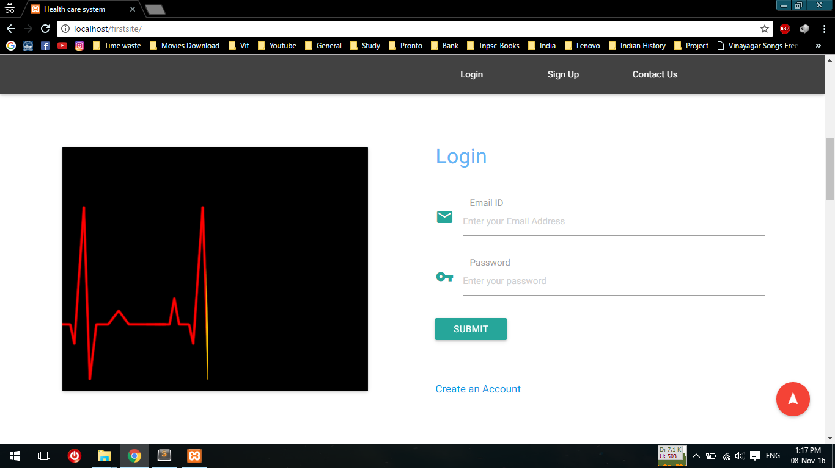

Sign up page:

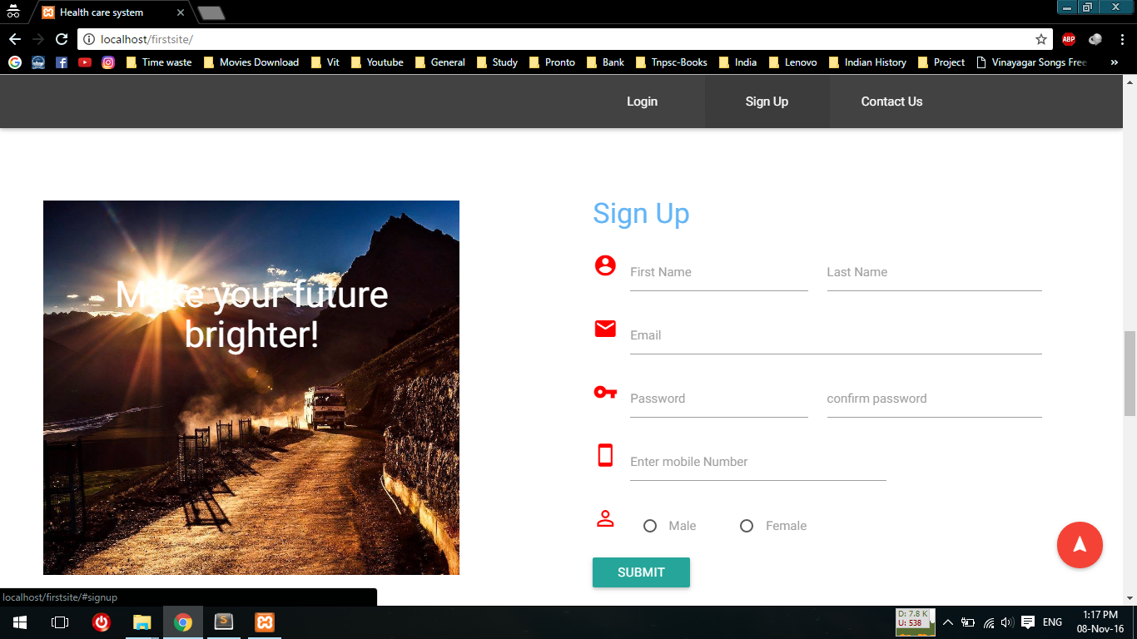

Feedback Page:

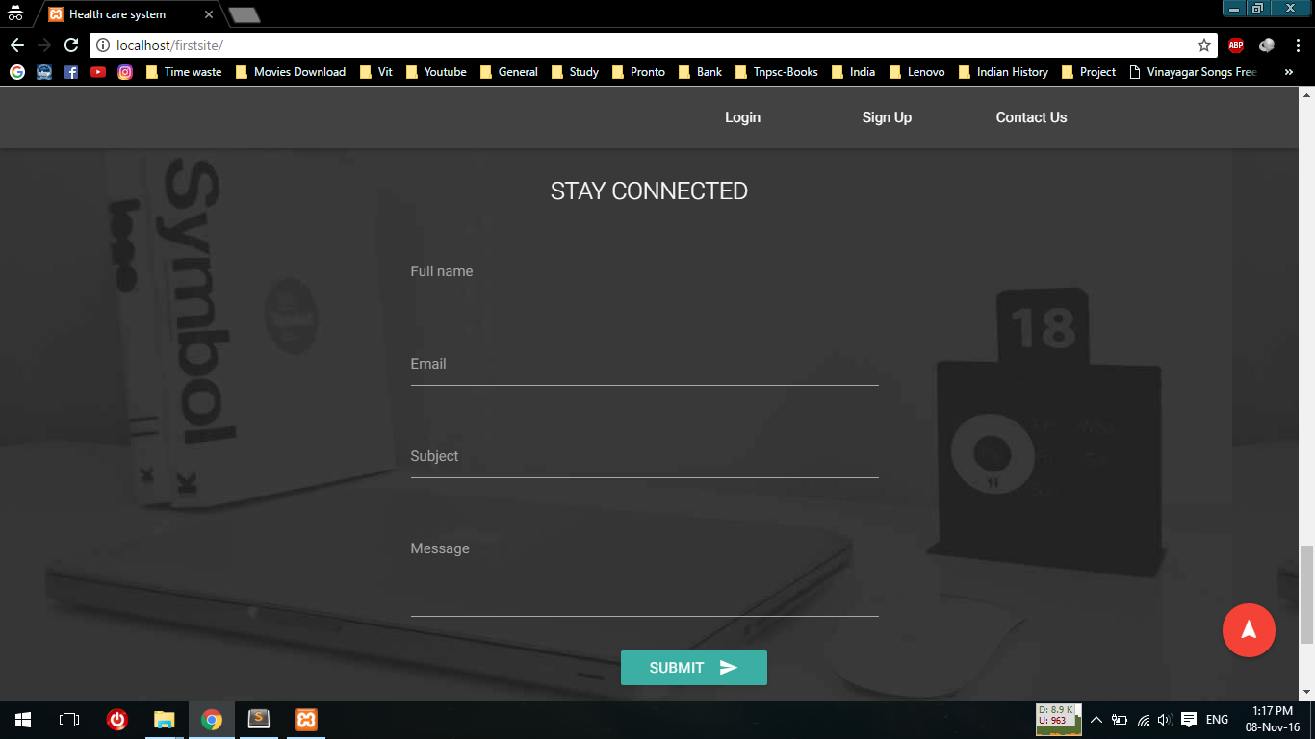

Home page:

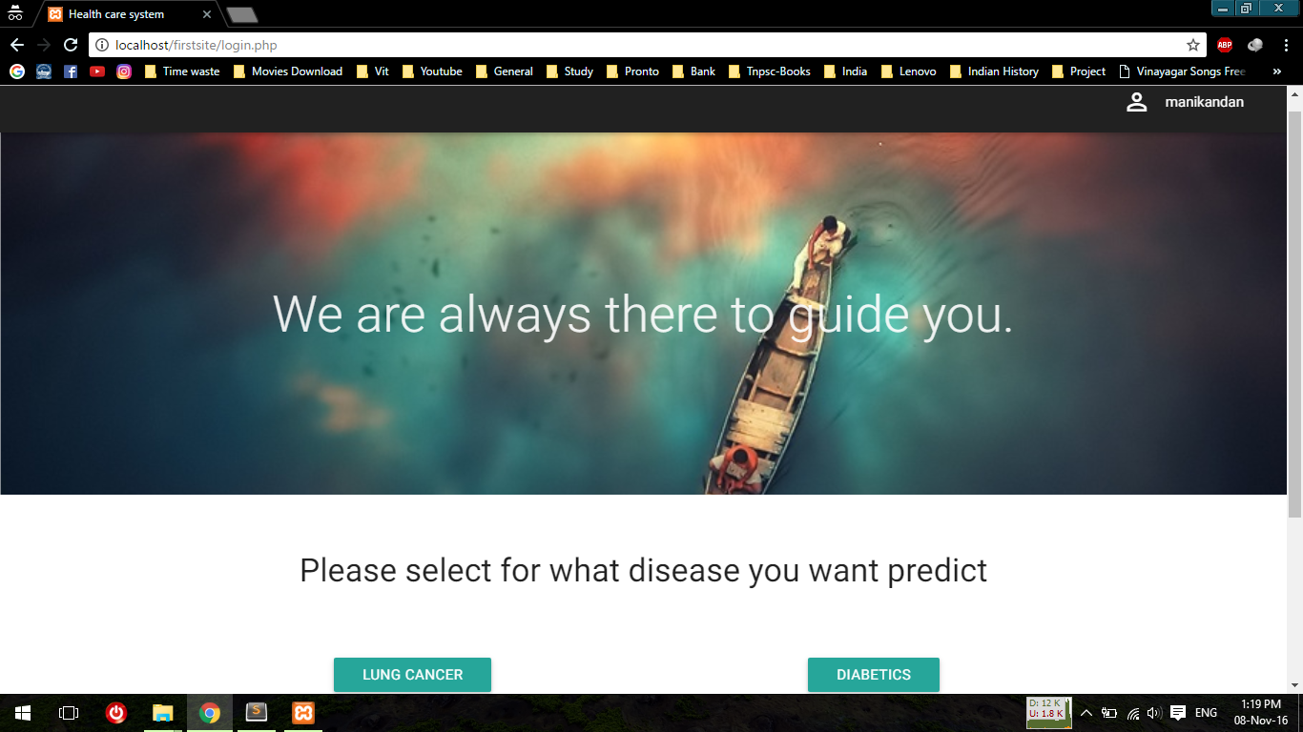

User form

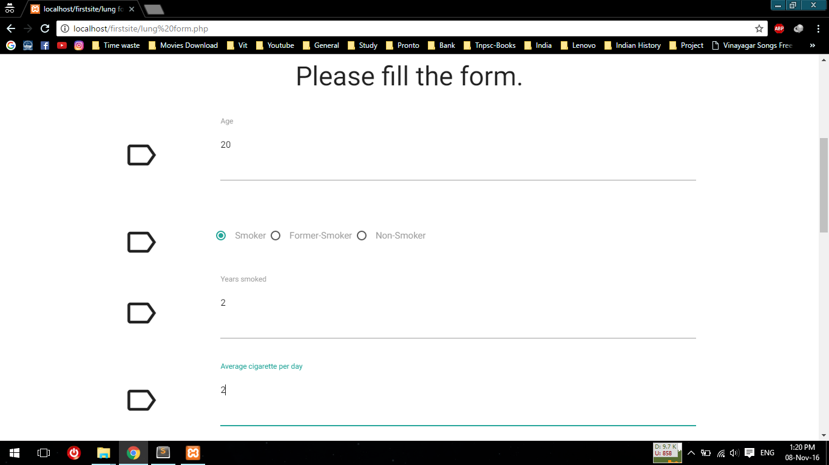

User form

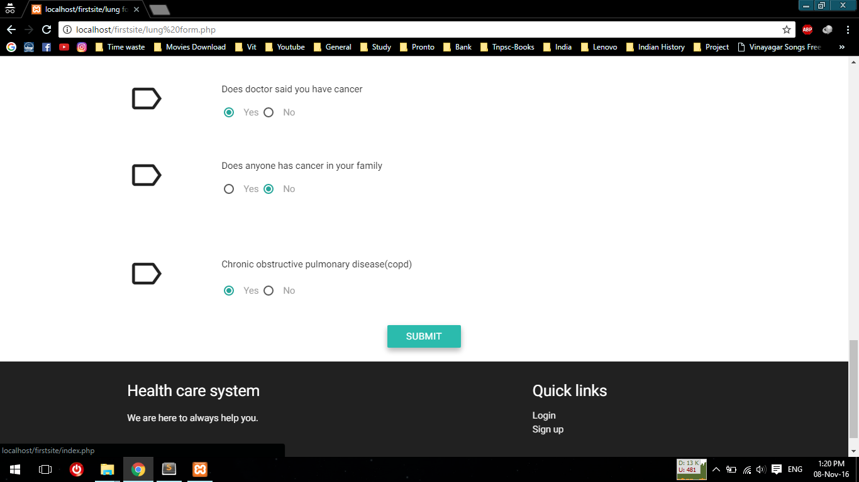

After submitting user input

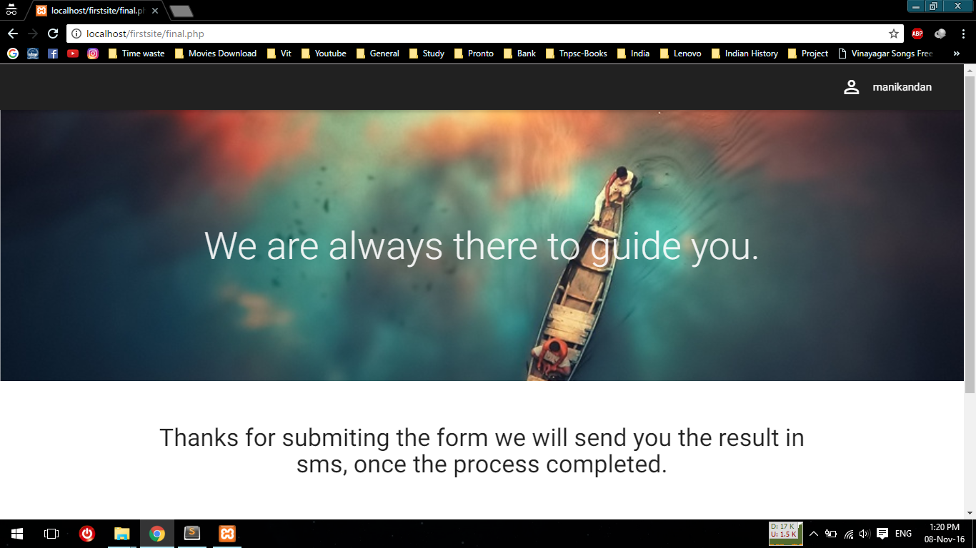

Output in r language:

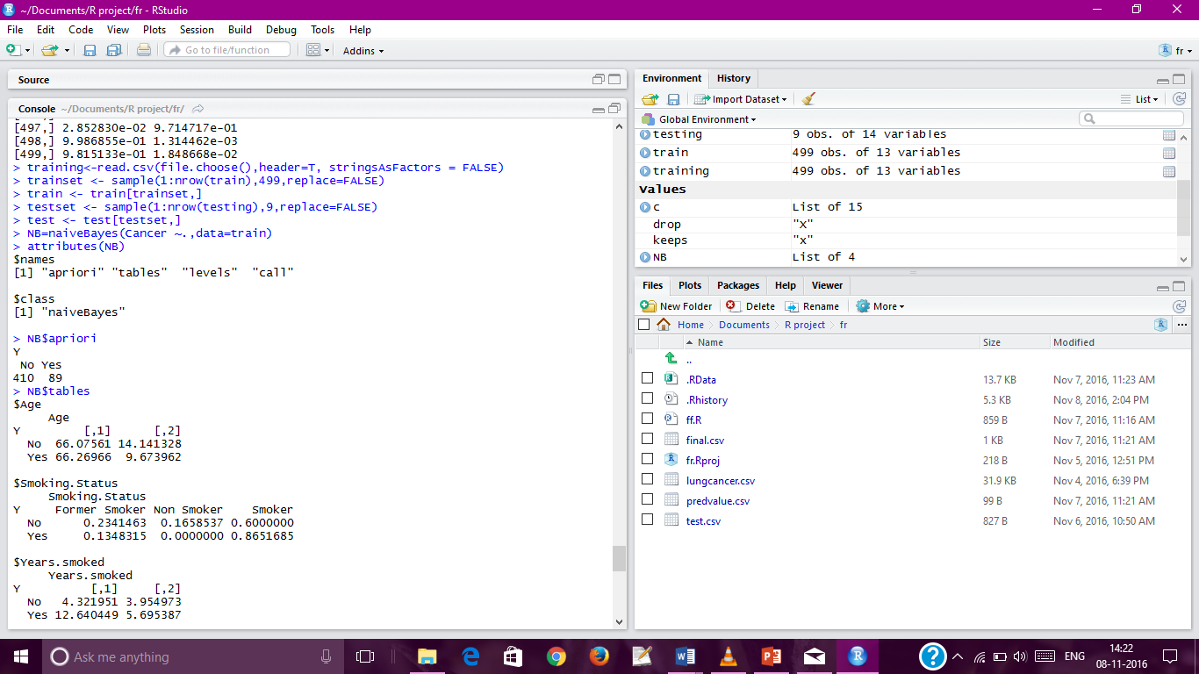

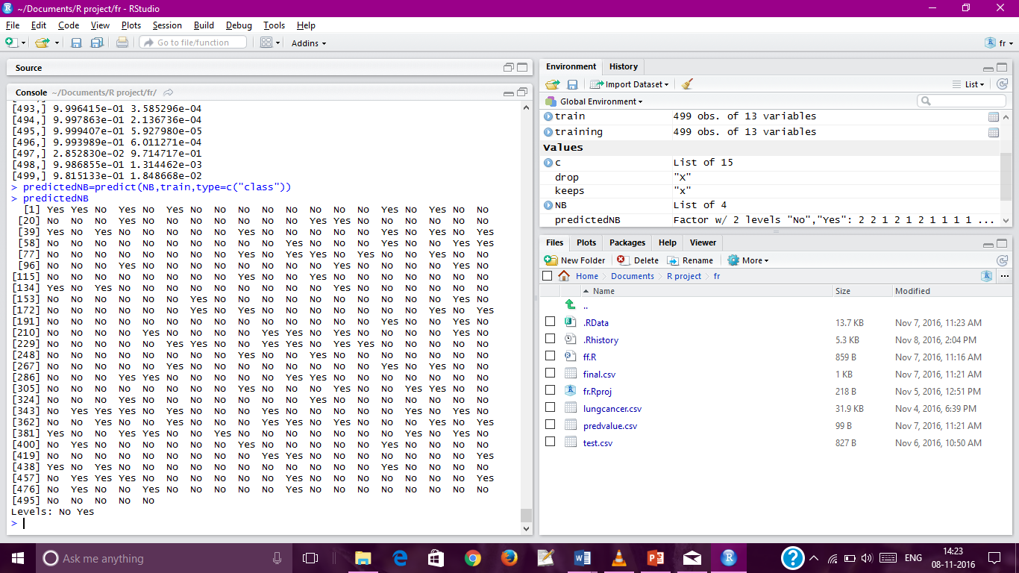

## Results Analysis:

**Analyzing the Dataset:**

The Previous dataset are analyzed using naïve Bayes algorithm and the conclusion of that result will be used to predict the new values.

**Analyzing the user input:**

The user input regarding their health are collected by the system and provide the results.

**Storing all data into database:**

All data can be stored in the database for easy retrieval and data processing.

**Providing results:**

The results can be provided to the user based on the inputs and the previous datasets.

**Notification/Recommendation to the user:**

The user can be notified by the system, if he/she having health problems.

## Discussion:

Naïve Bayes algorithm is used to analyze and predict the datasets. Naive Bayes is one of the best algorithm and having more accuracy rate comparing to other algorithms. In this the user input is collected by the system and the result can be provided. This system will consider most important factors from the user and predict the output/result. The proposed system will produce more accurate result.

# **Chapter 7**

# Conclusion and Future Work:

## Conclusion:

The proposed system will predict whether the user having the chances of getting any health problems based on their current health status. Naive Bayes algorithm can be used to analyze the dataset and produce the result. The techniques and methods used in this system will be more efficient and reliable. When using naïve Bayes algorithm for analyzing the dataset, it takes less time compared to other algorithm to produce the result.

## Future Work:

In future we use more algorithm to improve the accuracy of prediction of new data values. And also to implement more disease prediction in the system. Future work will be to increase the performance and efficiency of the system and to add more important features related to healthy life.

# **Chapter 8**

**REFERENCES**

**Conference Papers**

1. Rupali R.patel., Heart disease prediction system using naïve Bayes and jelinek-mercer smoothing (2014).

2. Akhilesh Kumar Yadav, Divya Tomar, Sonali Agarwal ,“Clustering of Lung Cancer Data using Foggy K-Means”(2013).

3. Data Mining Concepts and Technique by Jiawei Han and Micheline Kamber.

4. Smitha.T, V.Sundaram,”An Efficient Algorithm for Disease Prediction with

Multi-Dimensional Data” (2013).

**Books**

1. Data mining Algorithms Explained Using R by Wiley.

2. “An introduction to R” by W.N.Venables and D.M.Smith.